Art Guide

*This Art Guide is mad with the intention of assissting the art developers of Group 4 with the hopes that they would have an easier time for the project’s development*

Since our art style has been decided on being low poly, it would also need to go along with the aspects of 3D and First Person V.R. . For that reason, it would be important to have a better aesthetic to the game, than graphics. Which would also help us manage with our inexperience with 3D art and the limited time slot we have to create it.

1. **Assets:**
2. Models - Down to the nit grit, the first step is to model our subject. This process is what will make or break the final result. Starting off, we would need a good silhouette. making sure that the shape of the object reads well is very important, from all angles, especially if you are making a game where the player can inspect the object from all angles.

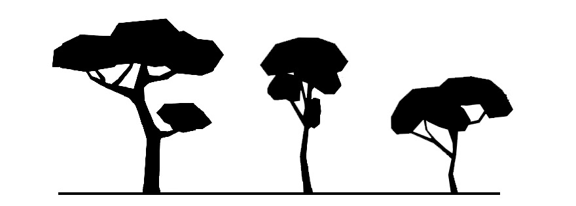

Making sure that the shape of the object reads well is very important, from all angles, especially if you are making a game where the player can inspect the object from all angles.

Secondly, in order to create an attractive object using only polygons, we would need to utilise the number of polygons in an obejct and the size of it. What do I mean by that? Well, think of polygons as a finite resource. The amount of polygons should reflect the objects.

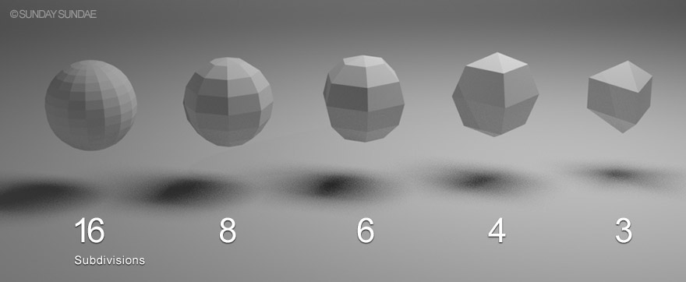

1. Shape - One thing that these geometric works mostly all do share are straight lines. There are those that incorporate circles and curves, but it’s something about those polygonal shapes, composed of facets, that makes us think “geometry!”

To determine your style within these limited options is the decision to use the oft-selected (and let’s be real, the simplest) option, the triangle, or to employ a variety of overlapping polygons, not all of which have to be the same as one another in number of sides or proportions.

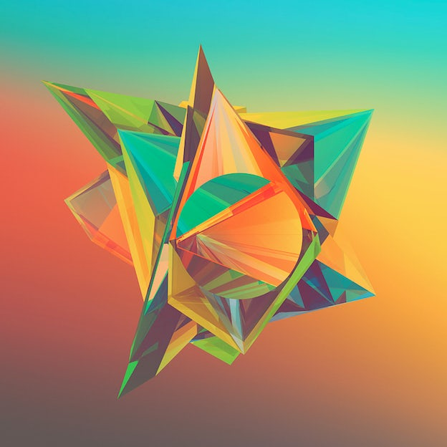

1. Textures – When it comes to textures, we should keep it simple. Since we have a low-poly art style, the texture should be at least a plain color. The reason is if we have a lot of complicated textures, then we would stray off from the art style we intended.
2. 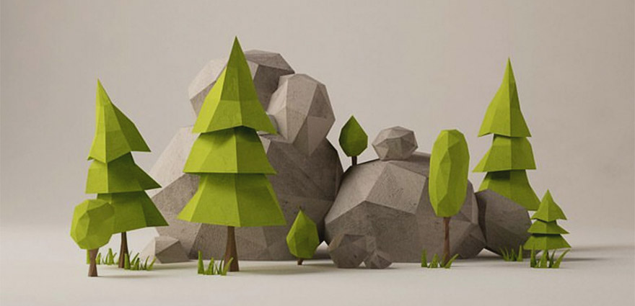Materials – As I mentioned above, the textures shouldn’t be complicated, but rather simple. But we needn’t make it ugly, with the help of lighting we would be able to deliver an attractive product, without sacrifising our lifespan.
3. **Bibliography**

<https://sundaysundae.co/how-to-make-low-poly-look-good/>

<https://en.99designs.nl/blog/tips/the-secrets-to-successful-geometric-low-poly-art/>

<https://www.wired.com/brandlab/2018/04/creating-art-virtual-reality-entering/>